Feedback Sprint 1

1. Header

Call buttons to start from right side as in the reference image below

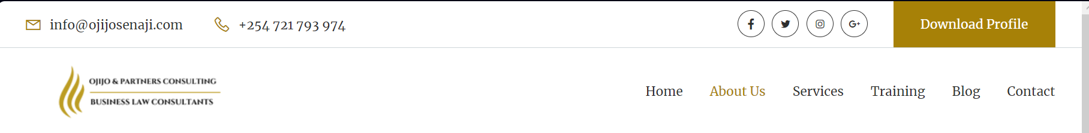

1. Landing page will only have 1 picture. There appears to be arrow keys to scroll. Arrows should not be the case.
2. Mobile view version. Cons at the bottom add Icon to take to our story page on the right. To have placement of icons as home market our story.
3. Page footer will also have contact us info below company profile. Which are company email & phone number.
4. On mobile view, the picture text placement as user scrolls down from home furniture home furniture and the next should be text picture text picture. Current case is text pic, pic text should not be the case

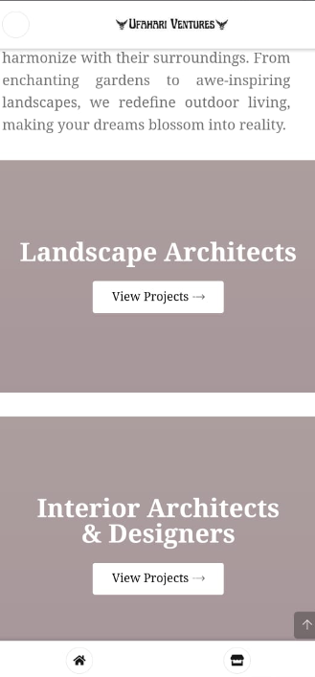

1. Our company colors are Gold & navy blue. Gold is our main colour.

The background color on the text in Home furniture, Installations & Institutions is navy blue



Reference site <https://ojijosenaji.com/about.html> & https://aceliafrica.org